**Lab 11: A Simple Microprocessor: The DDmini**

**Primary Objectives:**

1. Design and build the data unit for a microprocessor.

**Design**

8x4 RegFile design process

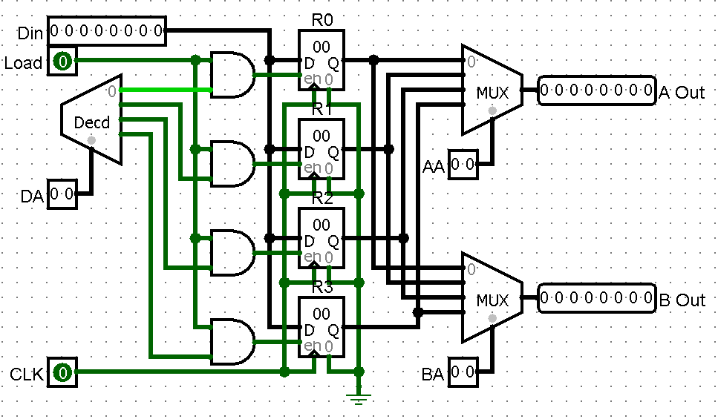

The required 8x4 RegFile was designed by modifying the given 4x8 RegFile.

Function select design process

The function select was built by using knowledge gained from Lab 8 and simply doing something similar for every function listed in the microoperation table in the lab pdf.

Data unit design unit

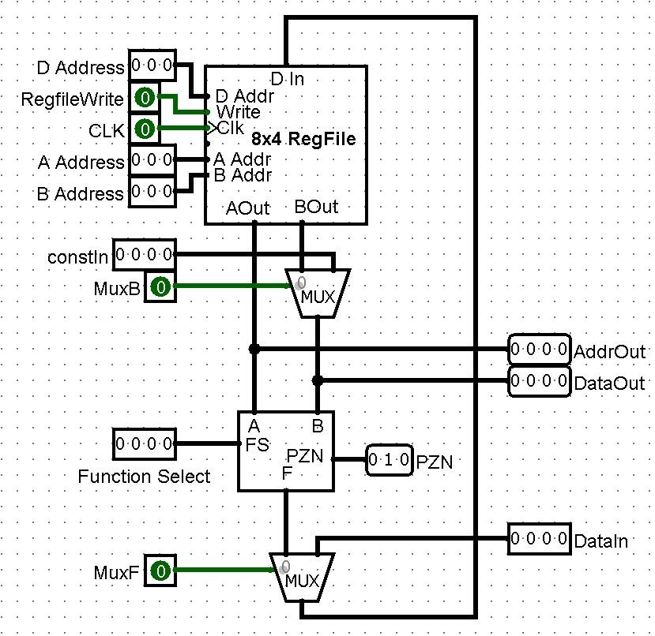

The full data unit was built by following the given data unit

**Implementation**

8x4 RegFile implementation



Through modifying the given 4x8 RegFile, this 8x4 RegFile was created.

Function select implementation



Using knowledge gained from lab 8 and the given microoperation table, this function select was created.

Data path implementation



Built entirely following the given data path.



Changed the various inputs that are controlled by the instructions from the control unit to the single 16-bit input.

**Testing**

8x4 RegFile testing

 RegFiles work as expected.

Function select testing



Function select works as expected.

Data path testing

The given opcodes are first translated into RTL and binary instructions that are given to the data path.





The instructions are then used to test (with constIn changed when necessary).



Data path works as expected with the given opcodes.

**Conclusion**

The device works as expected.